<https://www.edureka.co/blog/interview-questions/kubernetes-interview-questions/>

1. Kubernetes vs Docker

Advantages of kubernetes:

* 1. Auto Scaling
  2. GUI
  3. Updates can be roll back.

Advantages of Docker

1. Auto load balancing
2. Can share storage volumes with any container.
3. Scales faster than kubernetes.
4. Why we need kubernetes for Docker?

Docker builds containers and these containers communicate each other through kubernetes.

1. What is the difference between deploying applications on hosts and containers?

Hosts – all applications share the same host os and libraries

Containers – depends on the application and can run on any OS with a docker engine.

1. What is container orchestration?

Consider a application need 5 micro services. Now these micro services are put in individual container and they wont be able to contact each other. Kubernetes helps communication between containers.

1. Important features of kubernetes?

Automatic Scheduling

Self healing

Automated roll backs and roll outs

Horizontal scaling and load balancing.

1. What do you know about clusters in kubernetes?

Kubernetes is all about setting a desired state and the cluster manages the container operations so that the desired state is met.

1. What is Heapster?

Heapster is a cluster wide aggregator of data provided by kubelet running on each node.

1. What is Minikube?

Tool that makes kubernetes to run locally. Runs a single node kubernetes cluster on the VM.

1. What is Kubectl?

Provide command line tools for configuring kubernetes

1. What is a node?

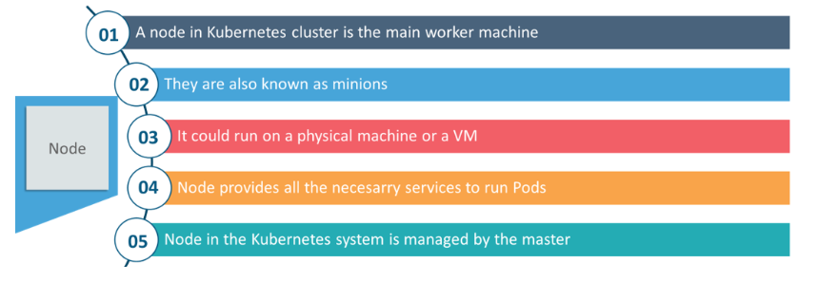

1. What are the different components of kubernetes architecture?

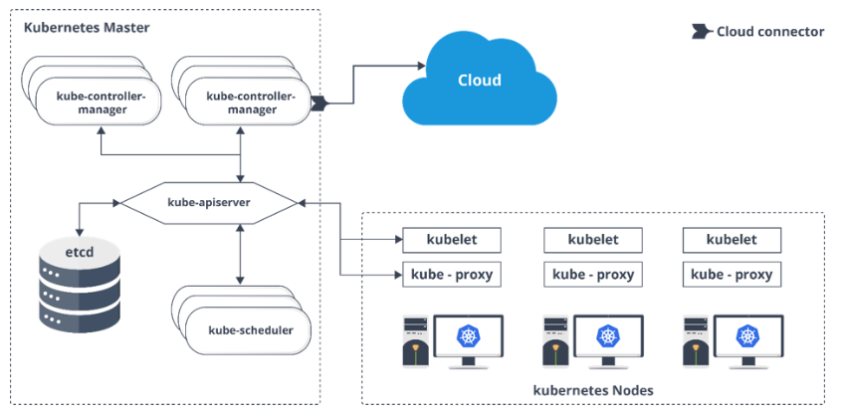

1. What is kube proxy

Runs on each and every node and can do simple TCP UDP packet forwarding across backends.

1. Working of master node in kubernetes?
   1. Kubernetes master controls the nodes and inside the nodes the containers are present.
   2. Inside, These individual containers are contained inside pods and inside each pod, you can have a various number of containers based upon the configuration and requirements.
   3. If the pods have to be deployed, then they can either be deployed using user interface or command line interface.
   4. Then, these pods are scheduled on the nodes and based on the resource requirements, the pods are allocated to these nodes.
   5. The kube-apiserver makes sure that there is communication established between the Kubernetes node and the master components.
2. What is the function of kube api server?

Establish communication between kubernetes master and nodes.

1. What is Kube Scheduler?

Kube scheduler is responsible for distribution and management of workload on the worker nodes.

1. What do understand by load balancing in kubernetes?

Internal load balancer: Automatically balances load and allocated the pods with required configuration.

External load balancer: Directs the traffic from external load to backend pods.

1. What are the different services of kubernetes?

